**Group:** Eco Buddies 2.0

Laura Haynes, Nicole Yunes Perez, Lina Clifford, Olivia Dinkelacker, Elizabeth Clark

**In-Class Data Exploration 1**

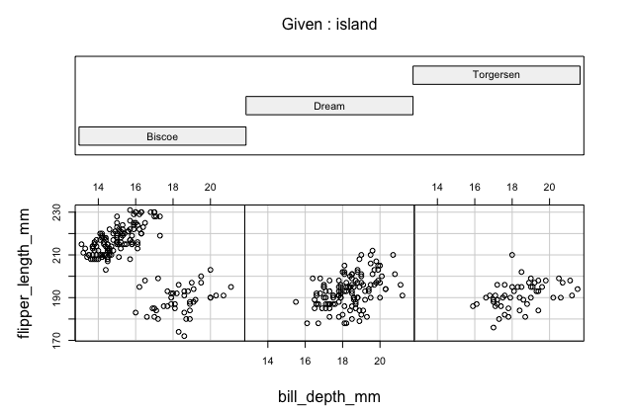

* Describe whether the plot shows a summary of the data, or all of the data points.
  + The islands are aggregated into bins, whereas the scatterplot below shows all the individual data points.
* Describe the insight your plot can provide, for example:
  + Are the data evenly distributed, or skewed?
    - The data is more evenly distributed amongst Dream and Torgersen islands, whereas on Biscoe island, the flipper length is more variable, skewing towards larger flipper length.
  + If your plot contains more than one variable, does the plot reveal any interesting relationships?
    - There are two clusters of points for the scatterplot of Biscoe, while the other two islands have one grouping of points. This could show that there are perhaps two species of penguins on Biscoe.

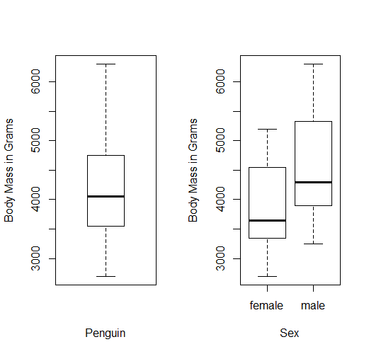

* Describe whether the plot shows a summary of the data, or all of the data points.
  + This boxplot shows a summary of the data, not all of the points.
* Describe the insight your plot can provide, for example:
  + Are the data evenly distributed, or skewed?
    - The data is evenly distributed for the penguin-body mass boxplot, but when broken up by male and female, the data is skewed toward upper values.
  + If your plot contains more than one variable, does the plot reveal any interesting relationships?
    - The plot reveals that female penguins tend to have a lower body mass than male penguins.